While we are freezing here
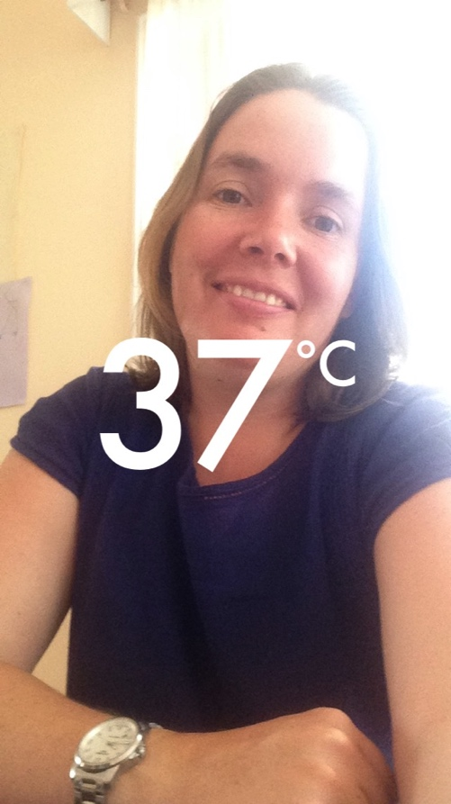
When Bronia and her family told everyone they were off to Sydney for a year, many people were jealous, picturing the wonderful warm weather and beach lifestyle we see on TV shows from Australia. While the family is enjoying being able to walk to the beach for a swim there have been some challenges getting used to a home of a very different standard.

A typical example of an Australian home
The listening text “How to Build a Solid House” (p.224) tells the well-known story of the Three Little Pigs who learnt that appropriate building materials are vital. However, choosing the right building materials and methods is not just about making sure the house is solid. It is also important to provide proper ventilation and insulation to maintain a comfortable temperature all year round. In Norway, where the weather is cold much of the year, there is considerable focus and many regulations to ensure that houses are built so that much of the heat stays in while maintaining appropriate air quality. In Australia there is much less focus on insulation and building standards in general are more relaxed.

Bronia is currently renting a house in the Eastern Suburbs of Sydney. When the family moved there in July it was mid-winter and they soon discovered that the Norwegian saying “det finnes ikke dårlig vær, bare dårlig klær” could just as well be adapted to their situation in Sydney. Only here a more appropriate version would be “there’s no such thing as bad weather, just bad buildings”. In the mornings the temperature outside was often as low as 4 or 5 degrees, and inside the house it was only a few degrees warmer. While they got used to putting on an extra jumper when they came inside, everyone told them their house would be a great house in the summer. Now that summer is here and the temperature has risen, however, Bronia and her family have discovered that while the marble tiles may keep their feet cool, a house that lets in cold also lets in heat.
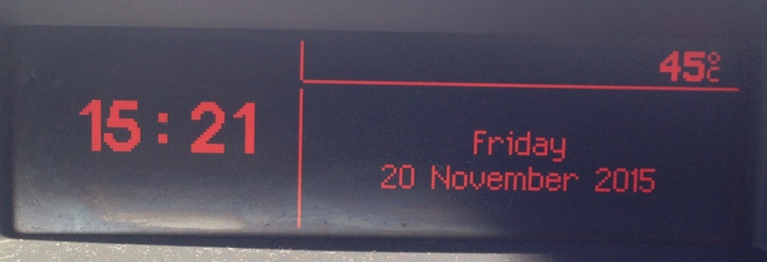
Watch the videos where Bronia shows you around her house and tells you about some of the issues they are experiencing.

Listen and understand
Answer the following question based on each of the videos.

- Welcome and windows:
  - What is the weather like on the day the video was filmed?
  - What do Australians call homes that are built using two leaves of brickwork with a cavity to reduce thermal transmission?
  - What does Bronia show you that is causing a problem with thermal transmission?
- Flat metal roof:
  - Describe the roofing on the house (both parts).
  - Tell a little more about the weather.
- Bedroom windows:
  - How can they get fresh air in their bedroom?
  - Why doesn’t Bronia like having the door open at night?
- Internal bedroom:
  - What is wrong with this bedroom?
  - What has been done with the door to try to improve the situation?
- External door:
  - What is wrong with this door?
  - What problems can it cause?
- Bathroom:
  - How can the bathroom be heated?
  - How is the bathroom ventilated to remove steam from hot showers?
- Ceiling:
  - Where is the roof leaking?
  - What maintenance work has been done following the leaks?
  - What other problem does Bronia suggest this has caused?

Explore
Now that you have seen some of the problems Bronia is having in her house you need to consider how they could have been avoided or overcome. Choose three of the videos and make a short video of your own in which you:
- Describe the issue
- Explain why it is a problem and what consequences it may have
- Provide an explanation of requirements in Norway relating to this issue
- Provide a potential solution
- Conclude by providing general information about the importance of ventilation and insulation
You may like to use this website, that gives an Australian perspective, for inspiration: http://www.yourhome.gov.au/

Write
You have now both heard about some issues in this Australian home and considered what you know that could improve it. While the house Bronia is renting is about 50 years old, single glaze windows, and ventilation issues such as Bronia describes are still very common in new houses. The website yourhome.gov.au is a partnership between the Australian government and the building and design industry to provide information about environmentally sustainable homes. There are, however, very few regulations that ensure that homes are built with the future in mind. It is often considered preferable to build a cheap house that may be expensive to heat and cool than to spend a little more to design and insulate appropriately and save money in the long run.

Write a text for people considering building their own home in Australia to persuade them to consider building an environmentally sustainable home. You should choose a particular area in Australia since there are a variety of climates within this large nation. You may like to structure your text as follows:
- An introduction about why sustainable homes are a good option and where this home would be built
- An explanation of options and recommendations for materials
- Details about options for energy conservation
- Details about options for water conservation
- A conclusion with an explanation of how these recommendations will benefit those living in the house, and the environment

