The Duke of Edinburgh's Award

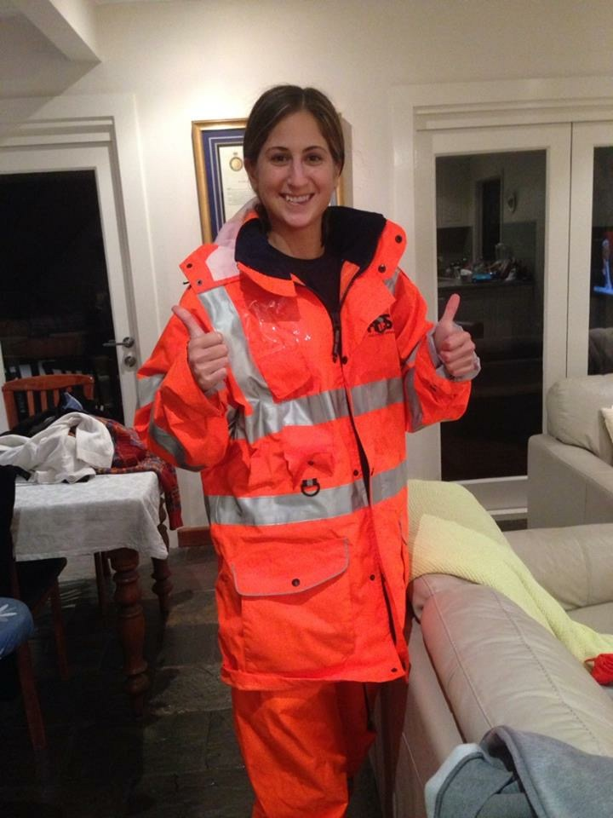
In Australia young people have many opportunities to be involved in extracurricular activities through their school. These activities are designed to teach them skills and build their confidence. Many of them are similar to those offered in Norway, such as sports, dance and music. The Duke of Edinburgh's Award is one of the most popular activities in Australia and it is all about growing as a person, and getting to know yourself and your capabilities. Perhaps this program even prepares young people to become role models.
Georgia and Daniel have spoken to English teacher Bronia Hamilton about their experiences in being part of The Duke of Edinburgh`s Awards.

1. Listen and understand

Listen to Georgia and Daniel talk about their experiences with the program. Take notes while you listen.

 | Notes | Words I need to look up
Georgia
Daniel

Answer the following questions based on what you just heard Georgia say.

- What level of The Duke of Edinburgh's Award is Georgia doing and why?
- What skills/activities has Georgia chosen?
- Why did The Duke of Edinburgh's Award suit Georgia so well?
- Why didn’t Georgia go to the beach every day?
- What has been the most challenging aspect of the award for Georgia?
- What is the SES and what do they do?
- What has Georgia gained from doing The Duke of Edinburgh's Award?

Answer the following questions based on what you just heard Daniel say.

- Why did Daniel decide to do The Duke of Edinburgh's Award?
- For his volunteer aspect Daniel worked with younger children. What were the three situations in which he was a role model for younger people?
- What did Daniel have to learn about in order to complete his adventurous journeys successfully?
- What was the “Urban Challenge?”
- How did Daniel experience volunteering?

2. Explore and discuss
Now that you have listened to what Georgia and Daniel have done to receive the award and how they have experienced the program, use the Australian Duke of Edinburgh's website (http://www.dukeofed.com.au/) to find out what other options are available.

Discuss: What would you choose to do and why?

3. Write
Create a persuasive text for your principal, the newspaper, the Minister for Education or some other person with influence to convince them that it would be a good idea for The Duke of Edinburgh's Award to be offered in Norway. You may like to use images from the official Duke of Edinburgh website, but remember to credit any images or information that you use. You are free to choose which ever text type you would like. Consider which type will be suitable for your intended audience and your purpose.

You may like to structure your text as follows:

- Introduction
- Details about what The Duke of Edinburgh's Award is
- What The Duke of Edinburgh's Award offers young people
- Why Norway should, and how Norway can, become involved
- Conclusion

