Design Dreams
By Bronia Hamilton

While browsing through my local paper I saw an article about young designers turned entrepreneurs. Marty Rowney (23) was one of the two young men and I decided to catch up with him to hear about how he turned his passion for illustration into a clothing business.

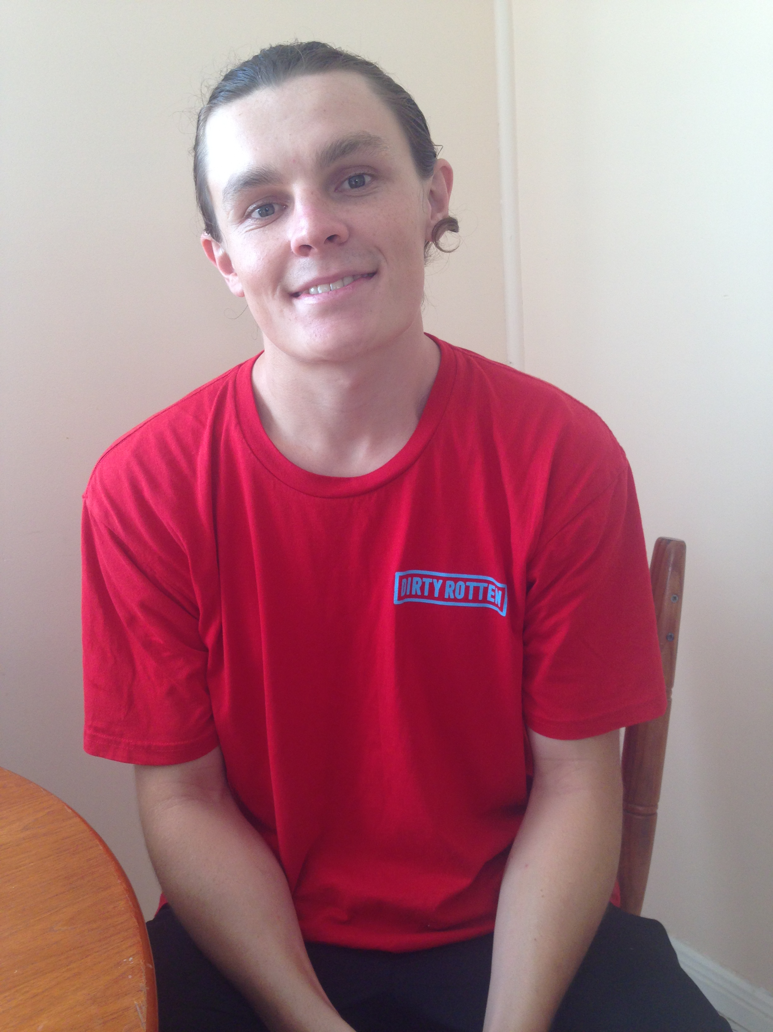
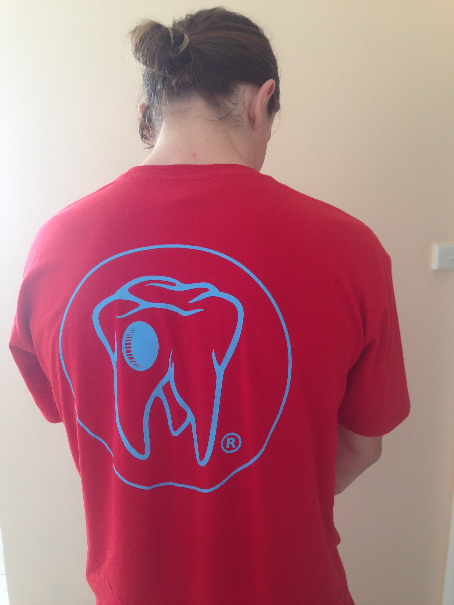

1. Listen and Understand

Read through the ten questions below. Then, listen to the interview. Take notes while you listen and answer the questions afterwards.

- Why did Marty start Dirty Rotten, and how old was he?
- Marty started out doing freelance design work. What does he discuss as the pros and cons of this work?
- What was Dirty Rotten’s first products and who were the first customers?
- How has Dirty Rotten marketed their clothing?
- Describe the process that Marty and his team go through to release a new line of clothes.
- What is one of the things that really drives Marty to keep doing “bigger and better”?
- What is Marty’s attitude to new technologies?
- Why doesn’t Marty design tattoos?
- What does Marty say about material choice?
- Summarise Marty’s advice for young designers.

2. Explore

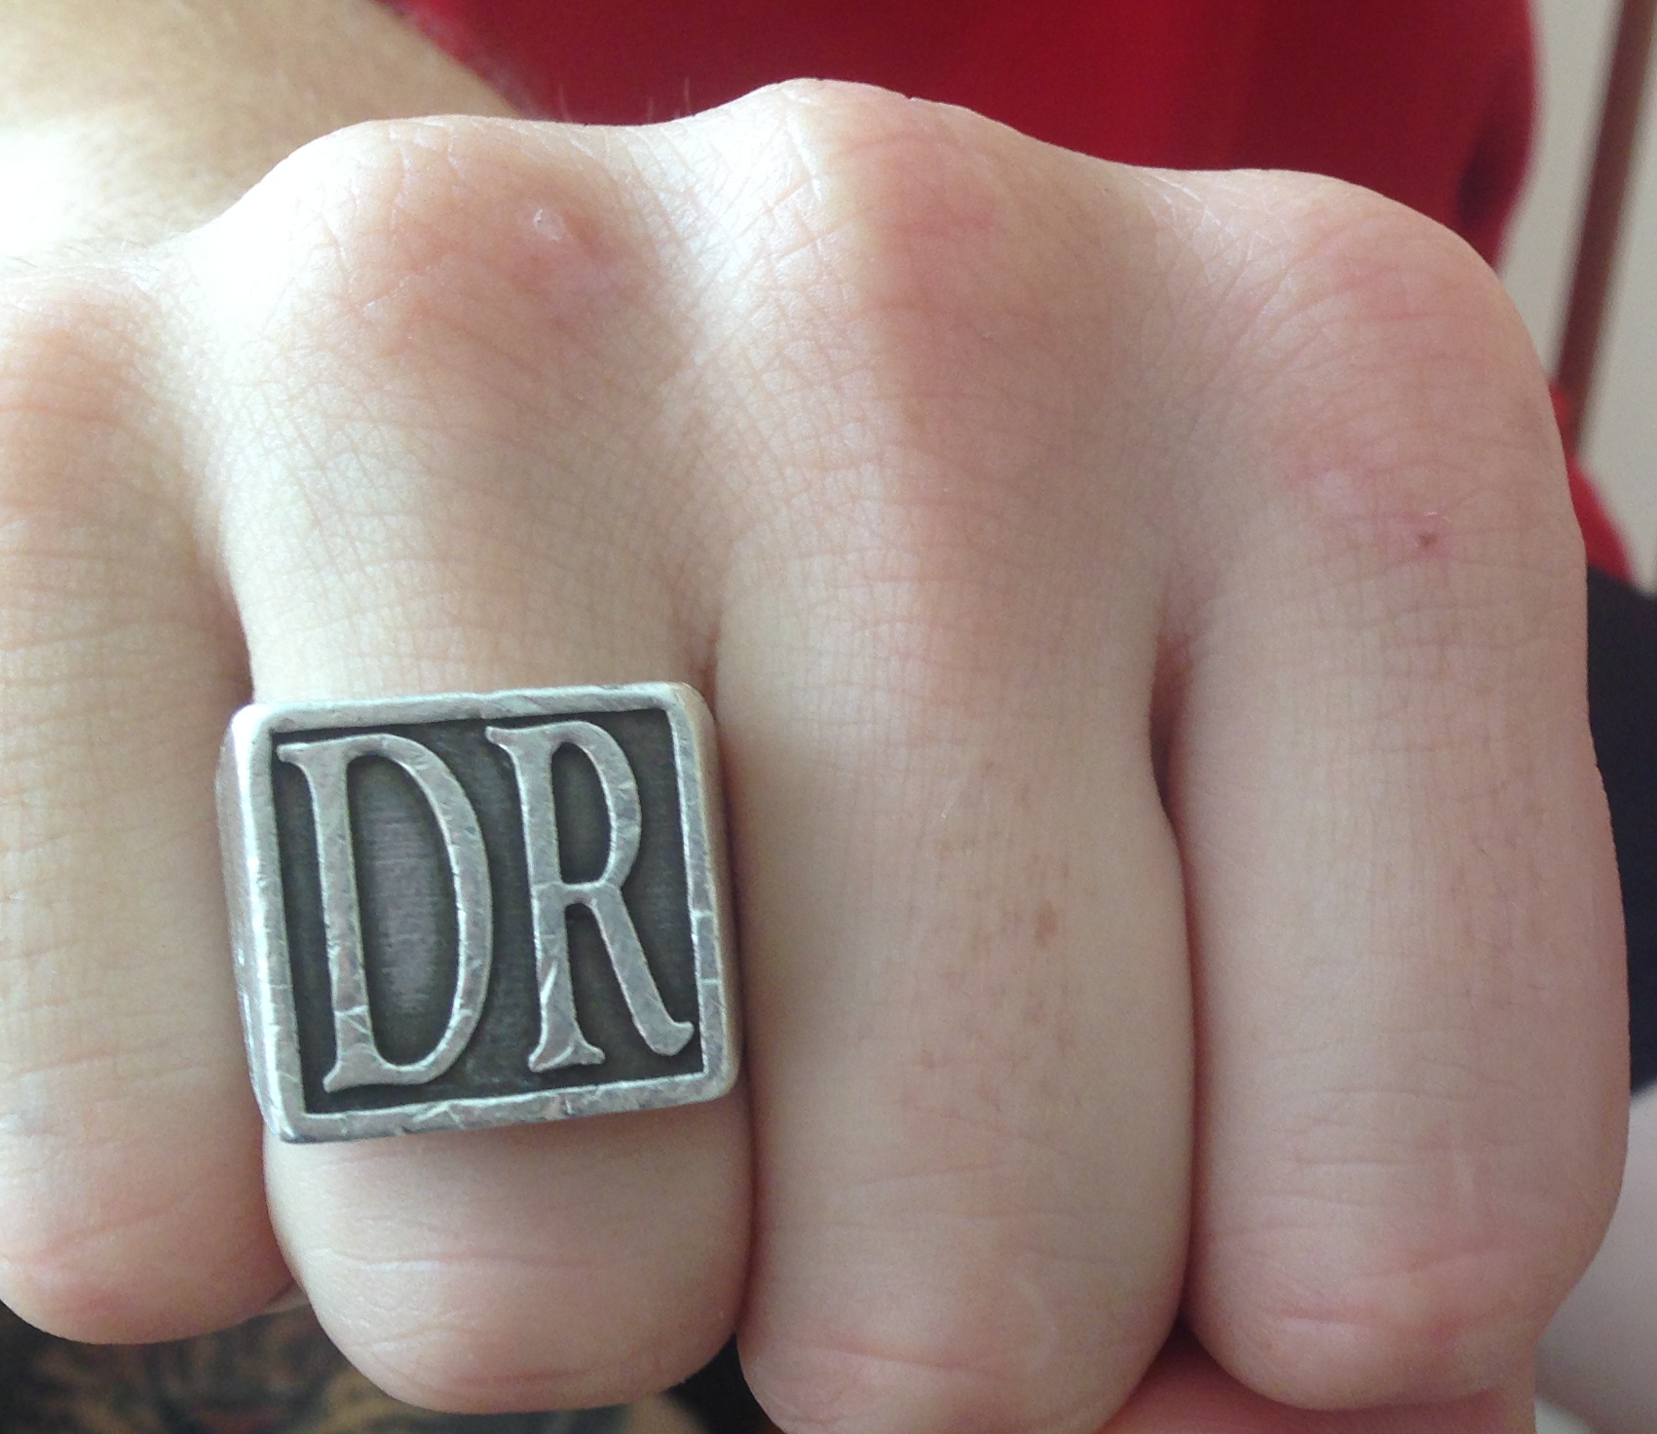
You have now heard Marty talking about turning his dream into a business.
- Develop a timeline of his journey giving as much detail as possible. You are welcome to use a mixture of images and text.
- Develop your own timeline and project five years into the future including what you hope to achieve.
- Go to www.dirtyrotten.com.au and have a look at Dirty Rotten on Facebook and Instagram. Put together a document (a text, a series of captioned drawings, a collage with commentary, a video or audio recording) giving your personal opinion of the way Dirty Rotten is profiled.

3. Write

Marty told us about how he likes to collaborate with friends and have an informal tone. Consider this as you:
- Write an email, as though you are Marty, to a singer you met last week at a festival and hung out with. You would like him/her to wear Dirty Rotten clothing as part of your marketing strategy. Once you have completed your email send it to a partner in your class.
- Read your partners email and write a brief analysis of the language and level of formality. You should choose specific examples on which to comment and discuss.

4. Talk

Choose one of the projects you have worked with in your Design subjects. Prepare for a conversation with your teacher, or a partner about the process of taking this project from idea to finished product. You should be ready to talk about:
- the various stages of the process
- challenges during the process and your responses to these challenges
- what you have learnt from the process

You may also talk about how you might market this product or what you see as a next step following this process.

Perhaps you can have images ready to show, or your product on hand to show what you are talking about. Either way, it is important that you consider and learn all the vocabulary you will need in order to talk comfortably about your product.

