Alternative Energy: Sunny Bins
By Bronia Hamilton

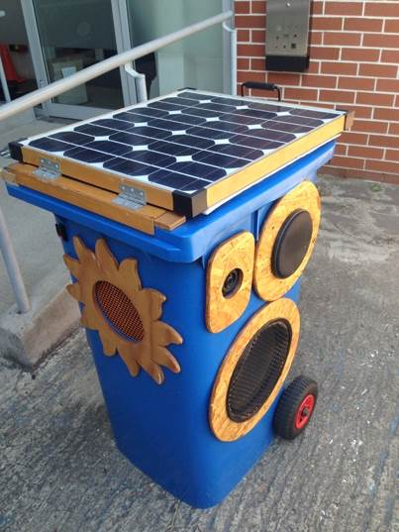
Sunny Bins are a great example of renewable energy on a smaller scale. The company uses a solar panel to charge a battery that powers a car stereo, all handily stored in a bin on wheels. Their portability means that they can be used whenever and wherever so they are perfect for protests or street parties.

English teacher Bronia Hamilton caught up with Peter Strong in his workshop. He told her about his work with Sunny Bins.

1. Listen and Understand

Listen to the interview. Then, answer the following questions.

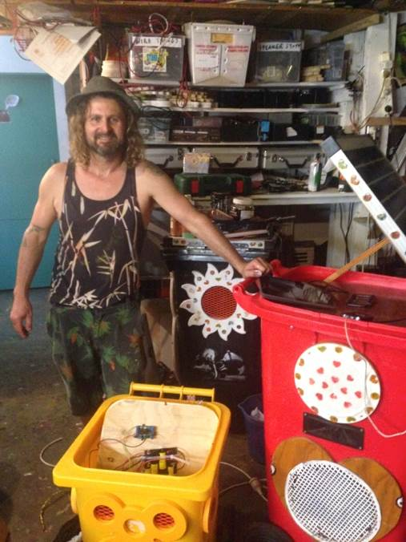
- When was the first wheely-bin sound system made in Australia?
- What did Peter do to make his own wheely-bin sound system?
- What did Peter and his friend do to improve the sound?
- What defines Sunny Bins in terms of wheely-bin sound systems and when were they first “born”?
- What are Sunny Bins used for on New Year’s Eve in Parramatta?
- What technical challenges has Peter had with the Sunny Buddy?
- What does Peter mean when he says “the dividends will be worth it once we nail it”? Hint: He is using a metaphor.
- Why did Peter decide to use solar energy to power his sound systems?
- How does Peter feel about solar power and its use in Australia?
- What does Peter consider to be some of the benefits of using Sunny Bins in communities?
- How does Sunny Bins cope with different weather?
- What is Peter’s advice to people who would like to design their own solutions to challenges?

2. Explore
Now that you have heard Peter talking about Sunny Bins, go to www.sunnybins.com and spend some time getting to know more about these solar powered portable sound systems.
Prepare and record a talk, interview or presentation in which you introduce:
- What Sunny Bins are
- How they work
- How they can be used
- Why you and your class should build your own version for your school

You can choose whom your audience is. For example, you may be trying to convince your classmates, your teacher, or the school principal. You can choose to simply use an audio recording or to use video.

3. Write
Peter talked about the role of Sunny Bins in protests since they were initially designed to allow protesters to broadcast their voice and music while on the move through Sydney’s streets. During your English course you have considered social or cultural issues in English speaking countries and have probably heard about movements such as the American Civil Rights movement, or more recently #blacklivesmatter. Perhaps you are interested in the Occupy movement, equal marriage rights or women’s rights in Pakistan and India.

Choose a political or social movement that you are familiar with and think about how technology could help them to stay safe, organize or spread their message, just like Sunny Bins did for Reclaim the Lanes. Write an explanatory text in which you describe a product that this movement should have (or have had if you choose a historical movement) to aid them in their protest. You can choose whether the audience for your text is electrical engineering colleagues or just other interested people. Who your audience is will determine how technical or simplified your explanations are.

You may like to structure your text as follows:
- Introduce the movement
- Introduce your product
- Explain how your product would help the movement
- Provide some technical details or specifications as to how the product would work (adjust the level of technicality to you audience and to your own skills)
- Conclude by describing how you envisage your product will make a change
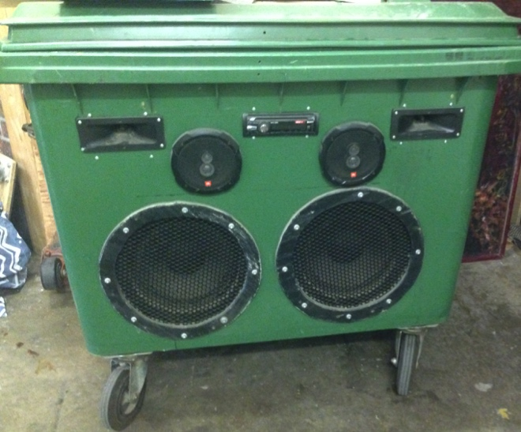

“You don’t wake up in the morning and say ‘I’ve got to invent something’.
You wake up in the morning and you say ‘There’s a problem to be solved’”

Barton and Dean Kamen (inventor of the Segway and Slingshot water purification system)

