Suffragette
- Feminism – A Fight for Equality

A: How would you define the term “feminism”?

B: Look for definitions of “feminism” in the Internet. Do they correspond to your definition of the word?
C: Based on the definition, who can be a feminist? Do you define yourself as a feminist?
D: Look for information about five of the following “feminists”. Write at least three keywords about each of them, and then compare your findings in groups or in class.

- Jane Anger
- Olympe de Gouges
- Sojourner Truth
- Mary Wollstonecraft
- Emmeline Pankhurst
- Florence Nightingale
- The Suffragettes
- Katti Anker Møller
- Simone de Beauvoir
- Betty Friedan
- Gloria Steinem
- The Riot Girl movement
- Shirin Ebadi
- Malala Yousafzai
- Emma Watson

E: On the Internet, look up and listen to Emma Watson’s “HeForShe” Campaign Speech in the United Nations. What is her message? Write at least three keywords while you listen, then share in class.
Emma Watson at the HeForShe Campaign 2014 - Official UN Video

F: Which challenges do we face concerning equal rights and gender equality in the world today?
This source might help you gain more knowledge: http://www.ohchr.org/EN/Issues/Women/WRGS/Pages/WRGSIndex.aspx

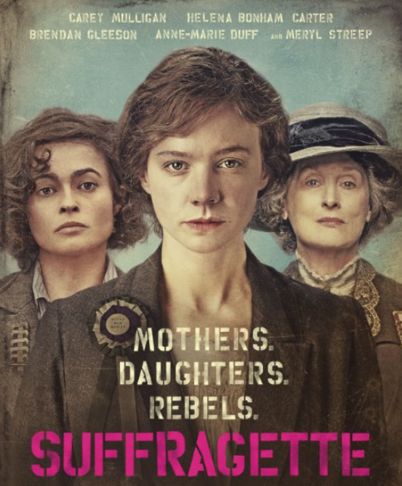
- See Suffragette – The Film

A: What was Maud Watts’ life like before she joined the Suffragette movement?

B: What made her decide to join the movement?

C: How did Maud’s life change after she joined the movement?

D: What kind of methods did the women use, and why?

E: How did most men react to the Suffragettes? Give examples.

F: Choose two of the characters from the film and answer the questions.
- How do they look and how do they behave?
- What is their social background and financial situation?
- What do they do during the film that is important in the plot?

G: What is your reaction to the information we get at the end of the film?

Writing a film review

Below is a step-by-step guide to writing a film review (Skills, Chap.5). After having watched the film Suffragette, write a review by following the steps.
Planning your text is useful. Therefore, make an outline first. Then, swap texts with a partner and give each other feedback, based on the steps below. Adjust your outline accordingly and continue by writing and handing in your text.

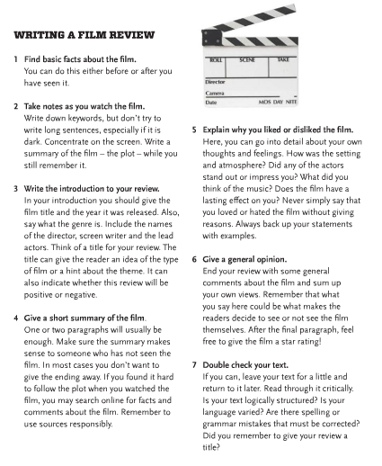

Læreplanmål (vg1):
- drøfte kultur og samfunnsforhold i flere engelskspråklige land
- drøfte engelskspråklige filmer og andre kulturuttrykk fra forskjellige medier

