Ecotourism for Turtles
In March 2016, we had an amazing family holiday on Fitzroy Island on the Great Barrier Reef and had the chance to visit the Cairns Turtle Rehabilitation Centre. Here we saw Ella in her tank and heard about how she has been treated for her injuries after being hit by a boat. Ella, like the other turtles at the centre, is cared for until she is able to care for herself, at which stage she will be rereleased into the wild.

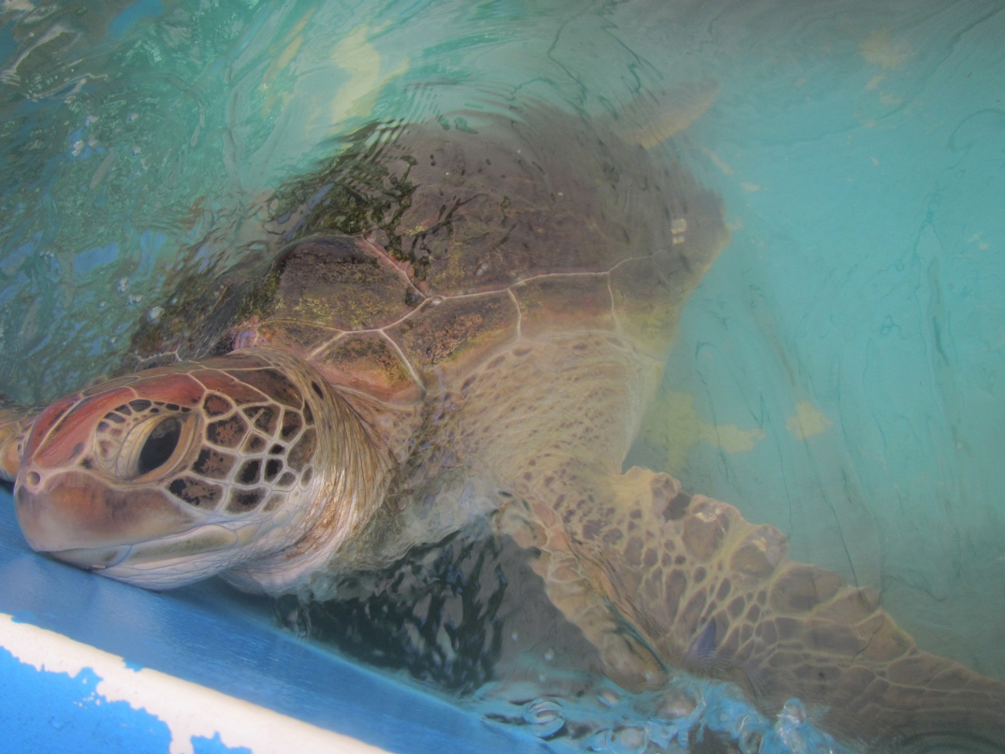

After our visit, I spoke to the Centre’s Director and Co-Founder, Jennie Gilbert to find out more about her work and her views on ecotourism.

1. Listen and Understand
Listen to the interview. Then, answer the following questions.
- How and when was the turtle rehabilitation centre started?
- What led to a dramatic increase in the number of turtles needing rehabilitation?
- How many volunteers are involved with the organisation?
- What other groups of people undertake placements with the Turtle Rehabilitation Centre?
- What does Jenny consider the benefits of opening up the Turtle Rehabilitation Centre for tourism?
- What are the downsides of opening for tourism on the Great Barrier Reef?
- What are Jenny’s views about Ecotourism regulations?
- Why isn’t the Rehabilitation Centre able to show all of their turtles?
- What does Jenny think is the role of young people who are involved in service and tourism?
- What is Jenny’s final piece of advice for young people?

2. Explore and share
Crowd funding and Keystone species were two of a number of concepts mentioned by Jenny. In pairs, divide the two concepts between you and spend 10 minutes researching them. Afterwards you should be able to explain the term to your partner.

3. Talk
Australia has so much to offer tourists, and is an amazing place to work in the tourism industry. A few years ago, Queensland Tourism launched a campaign to recruit young people from around the world to work in Australia. The campaign was so successful that Tourism Australia copied the campaign and offered six different jobs that applicants could apply for by sending in a 60-second video of themselves saying why they would be perfect for the job.
Source: www.tourism.australia.com/documents/Campaigns/Best-Jobs-Hero-Poster.pdf

Read this article and watch the video promoting the campaign http://www.news.com.au/travel/travel-updates/tourism-australias-six-best-jobs-in-the-world-in-detail/story-e6frfq80-1226590133752
Now decide on which of the jobs you would be most interested in and make your own 60-second video. Unfortunately, this competition is closed, but you never know, it may run again, and you will be well prepared to send in your application!

If you need some inspiration, you can find the videos of some successful applicants by searching online.

4. Write
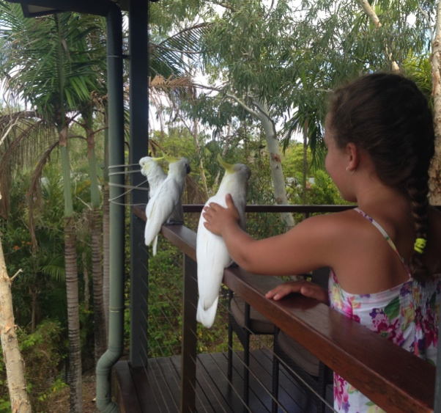
While staying on Hamilton Island we had many exciting encounters with the local bird life. Cockatoos, rainbow lorikeets and kookaburras all joined us for meals, trying, ultimately, to grab our food. It was certainly fun and exciting to interact with these relatively wild animals, but what we were eating was not exactly great food for them. Similarly, I loved swimming with the turtles and went looking for them each day, but on Fitzroy Island the turtles I saw were generally quite keen to get away from me. Many tourists want to see animals up close and experience some level of interaction, but this may not always be good for either the animals or the tourists. In Australia, turtles have been annoyed by divers holding onto their shells in order to be dragged along, while in Norway tourists have been injured and killed by polar bears.

Choose a particular tourist destination or a particular animal that many tourists wish to see, and write a short text from the point of view of a tour operator providing appropriate guidelines for tourists. You should justify why these guidelines should be followed to ensure that animals and people are protected from harm. Think carefully about the language that you use since you want to appeal to and attract tourists, make them feel confident about their safety and motivate them to consider their behavior in terms of what is best for the animals.

